TEN TIPS FOR CRUISING SAILORS
Now that cruising sailors are on their final preparations for departing New Zealand for the warmth of the tropical Islands, ‘tis is a good time to review the ways to obtain weather forecasts and/or provide position reports when at sea. These ten tips update and replace the edition published in “Tell Tales” last year (late April 2018).

- For those depending on Shortwave radio, ZLM/Taupo Maritime Radio offer a continuous 7/24 Trip reporting service see www.maritimenz.govt.nz/about/what-we-do/safety-and-response/maritime-radio.asp
The HIGH SEAS forecast for the area SUBTROPIC from MetService is read out in English via ZLM at 0903hr, and 2103hr NZST/NZDT on 6224 and 12356KHz and repeated an hour later on 8297 and 16531 KHz.
A copy of the Radiofax sked is at
www.metservice.com/_/files/marine-surf/radio/radiofax_schedule.pdf
Here is a current map of the forecast boundaries
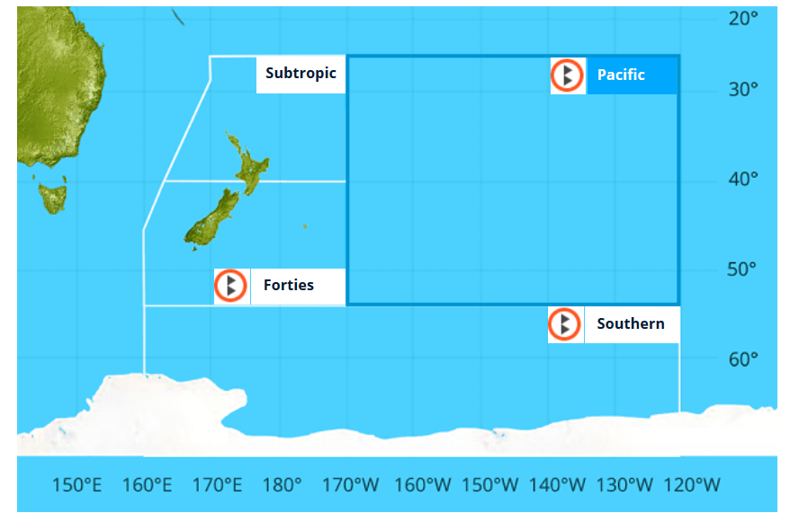

- Northland Radio ZMH292 is owned and operated by Peter Mott and provides a free of charge (donations welcome) check in service on multiple maritime frequencies. Northland Radio tracks vessels and has a formal policy for dealing with a missed check in. To use Northland Radio, operator requires Maritime Restricted Radio Operators Certificate (MRROC). In the maritime radio service, the callsign is assigned to the vessel, and in New Zealand it starts with ZM. See northlandradio.nz/faq/

- Gulf Harbour Radio ZMH286 offers a check in service with weather. Patricia and David keep track of boats that listen to their rollcall/weather service.
FIRST You need to register on www.ghradio.co.nz or via ghradio@xtra.co.nz with your boat and crew details and then you simply radio in your position and conditions, preferably each day via SSB. You may email your reports in via ghradio@cruisersat.net or send@yit.co.nz (see Tip 6), but all you need is SSB.
FROM 1 MAY to 25 NOV, Patricia/Dave are on air, Mon-Fri 07:15NZST on ZMH286 on 8752Khz or 8779KHz or 8297KHz in that order depending on interference. Other frequencies have been allocated for far away yachts. After the reports are taken, at around 07:30 NZST Dave does a round-up of the weather in each island group, including passage weather from east to west. The www.ghradio.co.nz website offers live streaming and has several good background weather and radio/comms articles.

- AMATEUR RADIO/Ham net: PACSEANET or The Pacific Seafarers’ Net is a ham (amateur radio) network providing a free of charge check in service on amateur frequency 14300KHz USB in the 20 metre band at 0300UTC. To participate, operator needs to hold an Amateur Radio Operators Certificate (General class or above). In the amateur radio service, the callsign is assigned to the licensed operator, so this is a different callsign from using a maritime callsign. In New Zealand amateur callsigns start with ZL. Position reports are received and reported in the well-know YOTREPS format (but missed calls may not be followed up). The net features 12 listening station dotted between Australia and Alabama.
See pacseanet.blogspot.com

- Smart phone apps: Some satellite phones now provide wifi that allow nearby smart phones to use apps. www.predictwind.com provides an app that supplies forecast model data, observations and, at the Professional Account level, tools for routing and comparing departure dates. It has a position tracking tool, and can help with iridium Go!

The Windy.com app is free of charge and it has a planned route plot option.
To make one: - "right click" anywhere on the map, this will open a small context window;
- choose "Distance & Planning"; - place your points on the map;
- in the "table of points" you just made, click the button label "share" in the bottom right corner;
- remember and use the short url link provided or the long URL in the top of your browser and "voilà"! You can also make one by building the URL manually if you are familiar with this. Each time you plug this "short" or "long url" in your browser, Windy will show the map and your planned route.

- YiT, Yachts in Transit, at www.yit.nz or mike@yit.nz has a smart phone app, and offers a subscription service to plot your reports and blogs on the web and to request weather information via coded emails. They also provide info on how to use iridium Go!, YB Tracking, or Garmin inReach for communications.

- EMAIL: Saildocs (saildocs.com) can relay the text details of a webpage even if you only have email and no access to the Internet. See weather.mailasail.com/Franks-Weather/Home
They allow you to download, for example, the latest edition of MetService warnings by sending an email, no subject necessary, to query@saildocs.com with message
SEND http://m.metservice.com/warnings/marine
For subtropics use SEND http://tgftp.nws.noaa.gov/data/raw/fq/fqps43.nzkl..txt
For the latest BRETT coastal forecast use
SEND http://m.metservice.com/marine/coastal/brett
They also use code words. For High Sea forecasts use SEND sopac or SEND nz.subtrop

- Fiji Fleet code. View a manual weather analysis map via EMAIL.
To download the latest Nadi Fleet code send an email to query@saildocs.com, no subject needed, saying SEND nadi-fleetcode
Or SEND https://tgftp.nws.noaa.gov/data/raw/as/asps20.nffn..txt
This can be viewed within the Fleet Code plug in OpenCPN.
Open the email and (on a PC) select and <Right> click the data, then <copy> or CTRL-C. Then, in OpenCPN’s Fleet code plugin, there are 4 option: Files, Text, Raw and Downloads. Select Raw and then <paste> or CTRL-V. Voila!, the map appears. I still have a copy of the old, no longer supported Fleet code viewing program call PhysPlot. If you want to try it, let me know.

- AIS: the AIS system plots coastal relayed data at marinetraffic.com, but oceanic data from satellite is only viewable by subscription.

- MetBob. Weather is a mix of pattern and chaos.
See my website at www.metbob.com to study my forecasting services.
WEATHERGRAM: These blogs are usually issued on a Sunday night NZ time with my evaluation of weather patterns around the South Pacific. They comment on what to AVOID, and help pick windows of opportunity for good sailing weather.
It is available in several different ways:
Internet illustrated edition is at metbob.wordpress.com, this has a click to follow option.
Internet translator and archive is at weathergram.blogspot.com
On Facebook at www.facebook.com/metbobnz

Via Saildocs
For a one-off: Send an email to query@saildocs.com, no subject needed with message
SEND nz.wgrm or SEND nz-weathergram
To subscribe: use SUB nz.wgrm (or SUBSCRIBE nz.wgrm)
To cancel: use CANCEL nz.wgrm or UNSUB nz.wgrm or UNSUBSCRIBE nz.wgrm

Via www.cruisersat.net
There are two net options. For full text (Ok for Sat Phone or HF SSB with sailmail/winlink) use weathergram@cruisersat.net,
and for the whole weathergram reduced to 4 SMS text messages, (for Satellite messengers such as Garmin inReach) use weathergram_short@cruisersat.net
To subscribe, send email to one of those email net addresses, no subject needed with message: subscribe boatname (replace boatname with name of your vessel, up to 20 characters). To unsubscribe, send the word UNSUBSCRIBE from your email address, or, if you have access to internet you can go to your profile -> "Nets / Rallies" tab and click on "Leave" button next to the net you want to leave. if you wish to only receive the weathergram (and not be disturbed by messages from other users) you can mute other calls by sending MUTE ON to the net address. To unmute, send MUTE OFF.
See cruisersat.net/docs for more info and info about getting weather warnings and forecast and see cruisersat.net/nets for a list of nets.
-=-=-=-=-=-=-=-=-=-= Bob McDavitt-=-=-=-=-=-=-=-=-=-=-=-=-=-=

