Wintering the Boat

With the prospect of all Islands in the Pacific locking their borders this year of Covid19 many crew have decided to leave their boats in a marina or on a mooring, or perhaps live on them but not go anywhere. Here are some suggestions for looking after the boat during the cooler and wetter months.

The Deck and Lines
We used to start the new season with Chameleon looking quite green around the gills. One side of the boat was quite shaded by the large power boat beside us so on that side lines and the deck had quite a bit of verdigris. Jan and Trevor on Villomee told me about the preventative cure.
First wash your boat down well and thoroughly wet all the lines that you have not put away. We curl the sheets and tie them close to the bow – away from the deck. We leave the furling lines in their usual position. Then use this product.

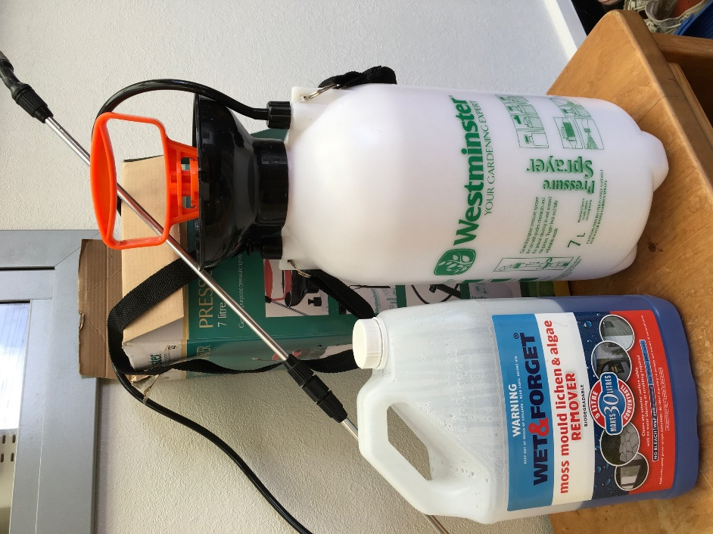

Wet and Forget have stores all over the country. Mix it as recommended and spray all the lines, edges of furled sails, the deck, and in fact anywhere that is likely to get affected by lack of sunshine. It will not harm anything. It was like a miracle for us. We did this at the end of April and it lasted right through the winter. As you can see I used half the container, diluted 1:5 for our 47’ monohull. This container was about $99 so share with a neighbour. Maybe the marina will purchase a sprayer that can be borrowed. They are available from hardware stores and are not expensive.

Inside the Boat
Trevor and Jan filled lids of jars with bleach and placed them in the bilges and on counter tops to help stop mould. And they wiped all white surfaces down with Wet and Forget Indoor for mould and mildew as it is a sanitising cleaner.
It is useful to leave an oil heater going in the main saloon which should keep the temperature up a bit and stop condensation. Ventilation is important so hopefully you have dorades angled for the breeze.

Food, Fridges and Freezer
If you are leaving the boat, clean and dry the fridge and freezer and leave them open. After you have emptied and defrosted, wipe the sides with a chlorine solution. All food should be removed if ants and other crawlies could possibly find it. This especially applies to flour and sugar containers that may have a head start with weevils anyway. If you think you will be throwing something away on your return then you may as well get rid of it now. Again, all surfaces should be cleaned of particulate dust and dirt.
We don’t seem to have a problem with cockroaches in NZ but the mix of boric acid in Sweetened condensed milk works a treat. I put it in bottle tops scattered all through the boat and this even worked in Mexico!

Clothing and Cupboards.
Try and space things out and leave doors open. This will minimize mustiness. And for the male crew – even once used clothes need to be washed before you leave.
Stay in a motel the night before you depart so that all bedding can be washed, dried and folded. Do not remake beds. I use the big plastic bags with the one way valve you can buy in the 2$ stores. Use them for clothes and towels and bedding. Evacuate with the vacuum cleaner. They keep everything fresh. Bring pillows into the area where you have the oil heater.

Leaks
You will know where these are so cover books with plastic and maybe tape the outside edges of hatches or fittings that are the cause of the problem.

Toilets
Flush well and leave them with some appropriate chemical - which you also flush through the lines. Ask whomsoever is checking your boat in your absence to flush the toilets while they are running the engine.

Water and Fuel Tanks
Have them filled before you leave. Your outboard fuel can be given to land based friends for their lawnmower!

Wetsuits and Water toys
These need to be fresh water cleaned and dried before putting away.

This is a first draft! Second actually as Trevor and Jan contributed. I am sure there are a lot of helpful hints coming from you guys so please let me know and I will add them so others can benefit.
ghradio@xtra.co.nz

